Level 1 Question 1:
Given that the half-life of Carbon-14 is 5,730 years, how many half-lives would something go through in 28,650 years?
A. 2 half-lives
B. 4 half-lives
C. 5 half-lives
D. 6 half-lives

Level 1 Question 2:
If I have 4 grams of Carbon in the original sample and it goes through 2 half-lives, how much carbon do I have left?
A. 3 grams
B. 0 grams
C. half a gram
D. 1 gram

Level 1 Question 3:
How many half-lives would it take to reduce the amount of radioactive material to 12.5% of the original amount?
A. 2 half-lives
B. 3 half-lives
C. 4 half-lives
D. 5 half-lives
Level 1 Question 4:
What percentage of the original carbon 14 would remain in a sample of wood from a shipwreck if it was: 10,400 years old?
A. 20%
B. 12.5%
C. 25%
D. 3%
Level 2 Question 1:
The era of the geological time scale that represents “middle life” is the...?
A. Mesozoic
B. Cenozoic
C. Precambrian
D. Cambrian

Level 2 Question 2:
The shortest and most recent era of the time scale is the…?
A. Mesozoic
B. Cenozoic
C. Precambrian
D. Cambrian

Level 2 Question 3:
Which is known as the “Age of Fishes”?
A. Permian
B. Silurian
C. Devonian
D. Paleozoic

Level 2 Question 4:
Arrange from Oldest to Youngest?
A. Cenozoic, Mesozoic, Paleozoic, Precambrian
B. Mesozoic, Paleozoic, Precambrian, Cenozoic
C. Paleozoic, Precambrian, Cenozoic, Mesozoic
D. Precambrian, Paleozoic, Mesozoic, Cenozoic

Level 3 Question 1:
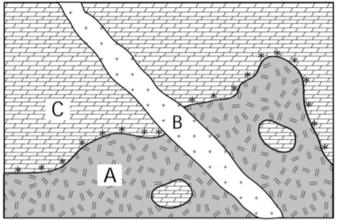
Put in order from youngest to oldest?
A. BCA
B. BAC
C. CAB
D. ABC

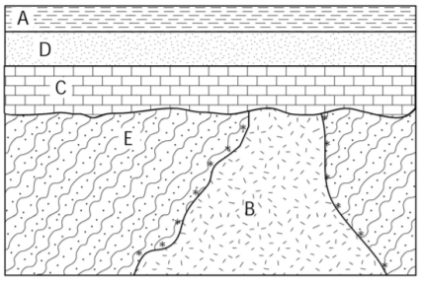
Level 3 Question 2:
Put in order from youngest to oldest?
A. BCDAE
B. DCBEA
C. EBCDA
D. ADCBE

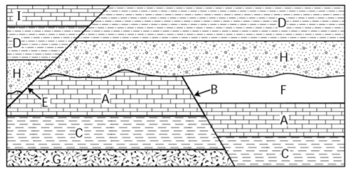
Level 3 Question 3:
Put in order from youngest to oldest?
A. EIDHBFACG
B. DHBFACGEI
C. GCAFBHDIE
D. DHBFACEIG

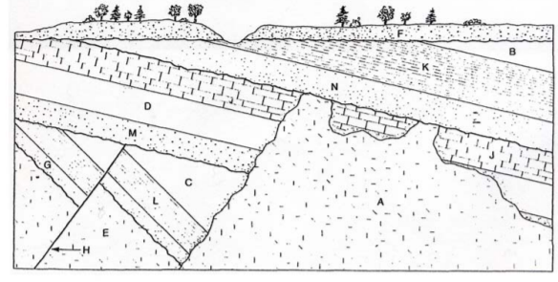
Level 3 Question 4:
Put in order from youngest to oldest?
A. BFKNAJDMHCLGE
B. KNAJDMHCLGEFB
C. FBKNAJDMHCLGE
D. FBKNAJDMHLCEG

Level 4 Question 1:
Fossils that are useful in establishing the absolute ages of rocks
A. Called index fossils
B. Occupied only a small geographical area in Earth’s history
C. Contain abundant amounts of radioactive material
D. Once abundant and occupied a short geological time period

Level 4 Question 2:
In a rock formation, clamshells, snail shells, and ammonites are found in several of the layers. Only one of the layers contains fossils of brachiopods. The geologist studying the formation concluded that?
A. The clamshells were deposited in an ancient shallow sea
B. The snail shells belong to an extinct marine species
C. The Brachiopods found could be considered index fossils
D. Not enough information was present and further investigation needed

Level 4 Question 3:
A rock sample used for radiometric dating contained a ratio of 3 stable daughter atoms for 1 parent atom. The age of the sample is most likely?
A. 1 million years
B. 6 million years
C. 3 million years
D. 12 million years

Level 4 Question 4:
The age of the Earth is now determined by?
A. Radiometric dating of the oldest terrestrial rocks
B. Use of fossils and the Law of Faunal Succession
C. Dating the oldest sediments found on the continents
D. Dating of meteorites, which are believed to be the same age as the Earth

